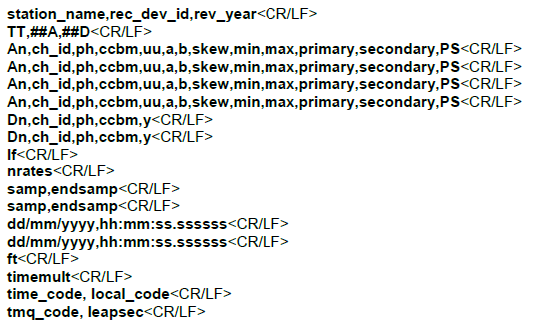

where

**An** is the analog channel index number. Critical, numeric, integer, minimum length = 1 character,

maximum length = 6 characters, minimum value = 1, maximum value = 999999. Leading zeroes or spaces are not required. Sequential counter from 1 to total number of analog channels (##A) without regard to recording device channel number.

**ch_id** is the channel identifier. Critical, alphanumeric, minimum length = 1 character, maximum length = 128 characters.

**Ph** is the channel phase identification. Non-critical, alphanumeric, minimum length = 0 characters, maximum length = 2 characters.

**ccbm** is the circuit component being monitored. Non-critical, alphanumeric, minimum length = 0 character maximum length = 64 characters.

**uu** are the channel units (e.g., kV, V, KA, A, A RMS, A Peak). Critical, alphabetic, minimum length = 1 character, maximum length = 32 characters. Units of physical quantities shall use the standard nomenclature or abbreviations specified in IEEE Std 260.1TM-1993 or IEEE Std 280TM-1985 (R1996) or ISO 80000-1. Numeric multipliers shall not be included. Standard multiples such as k (thousands), m (one thousandth), M (millions), etc. may be used. The word "NONE" is to be used for unit-less values.

**a** is the channel multiplier. Critical, real, numeric, minimum length = 1 character, maximum length = 32 characters. Standard floating point notation may be used (Kreyszig [B6]).

**b** is the channel offset adder. Critical, real, numeric, minimum length = 1 character, maximum length 32 characters. Standard floating point notation may be used

The channel conversion factor is ax+b. The stored data value of x, in the data (DAT) file, corresponds to a sampled value of (ax+b) in units (uu) specified above. The rules of mathematical parsing are followed such that the data sample "x" is multiplied by the gain factor "a" and then the offset factor "b" is added. Manipulation of the data value by the conversion factor restores the original sampled values. See Annex E for an example.

**Skew** is the channel time skew (in μs) from start of sample period. Critical, real number, minimum length = 1 character, maximum length = 32 characters. Standard floating point notation may be used (Kreyszig [B6]).

The field provides information on time differences between sampling of channels within the sample period of a record. For example, in an eight- channel device with one A/D converter without synchronized sample and held running at a 1 ms sample rate, the first sample will be at the time represented by the timestamp; the sample times for successive channels within each sample period could be up to 125 μs behind each other. In such cases the skew for successive channels will be 0; 125; 250; 375...; etc.

**Min** is the range minimum data value (lower limit of possible data value range) for data values of this channel. Critical, numeric (integer or real), minimum length = 1 character, maximum length = 13 characters, minimum value = -3.4028235E38, maximum value = 3.4028235E38.

**Max** is the range maximum data value (upper limit of possible data value range) for data values of this channel. Critical, numeric (integer or real), minimum length = 1 character, maximum length = 13 characters, minimum value = -3.4028235E38, maximum value = 3.4028235E38. Note: max ≥ min always.

**primary** is the channel voltage or current transformer ratio primary factor. Critical, real, numeric, minimum length = 1 character, maximum length = 32 characters.

**secondary** is the channel voltage or current transformer ratio secondary factor. Critical, real, numeric, minimum length = 1 character, maximum length = 32 characters.

**P or S** is the primary or secondary data scaling identifier. The character specifies whether the value received from the channel conversion factor equation ax+b will represent a primary (P) or secondary (S) value. Critical, alphabetic, minimum length = 1 character, maximum length = 1 character. The only valid characters are: p,P,s,S.

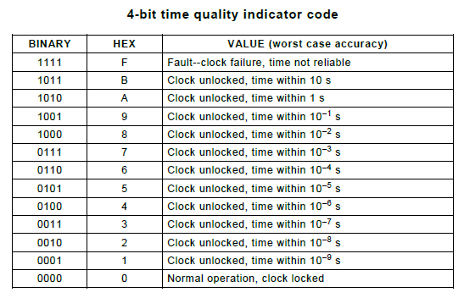

**timemult** is the multiplication factor for the time differential (timestamp) field in the data file. Critical, real, numeric, minimum length = 1 character, maximum length = 32 characters. Standard floating point notation may be used (Kreyszig [B6]).

**time_code** is the same as the time code defined in IEEE Std C37.232-2007.Critical, alphanumeric, minimum length = 1 character, maximum length = 6 characters.

**local_code** is the time difference between the local time zone of the recording location and UTC and is in the same format as time_code. Critical, alphanumeric, minimum length = 1 character, maximum length = 6 characters.

**Leapsec** is the leap second indicator. It indicates that a leap second may have been added or deleted during the recording resulting in either two pieces of data having the same Second of Century time stamp or a missing second. Critical, integer, numeric, minimum length = 1 character, maximum length = 1 character. The only valid values are:

• 3 = time source does not have the capability to address leap second,

• 2 = leap second subtracted in the record,

• 1 = leap second added in the record, and

• 0 = no leap second in the record.

**tmq_code** is the time quality indicator code of the recording device's clock. It is an indication of synchronization relative to a source and is similar to the time quality indicator code as defined in IEEE Std C37.118TM. Critical, hexadecimal, minimum length = 1 character, maximum length = 1 character. The time quality value used shall be the quality at the time of time stamp.